**INTRODUCTION**

Swanson Mountains Management Group’s commitment to corporate social responsibility has made voluntary carbon management a business priority. The company also recognises that it will be exposed to the rising costs of electricity and emission-intensive goods, which are likely to occur as a result of the incoming Tasland Emissions Trading Scheme (ETS). Swanson Group is therefore considering a number of projects to reduce its power use, and ultimately, its carbon footprint.

As the Carbon and Energy Manager at Swanson Group, the company’s Board of Directors has asked you to undertake a financial appraisal of several low-emission technologies that can be implemented at its headquarters and branch offices. It has also charged you with developing a Marginal Abatement Cost Curve (MACC) to assist it in ranking the abatement projects in terms of the lowest cost per tCO2e.

For each project you will conduct a financial and emissions analysis following these steps:

For each project you will conduct a financial and emissions analysis by following these steps:

* Step 1: Net Present Value analysis
* Step 2: Marginal abatement cost analysis

After completing the analyses of all four projects, a Marginal Abatement Cost Curve (MACC) will be generated. You will then interpret your MACC, to determine which projects should be implemented under different scenarios.

**PROJECT 1**



|  |  |
| --- | --- |
| **Lighting retrofit** | |
| **Project lifetime** | 5 |
| **Upfront Capital Cost (CAPEX)** | $2,500 |
| **Exp. Annual Savings** | $2,000 |
| **Exp. Annual Operation Cost (OPEX)** | $200 |
| **Annual Emissions Reductions (tCO2e)** | 35 |
| **Interest rate** | 8% p.a. |

**Project description:** Changing incandescent lamps to more energy efficient low-watt compact fluorescent lamps (CFLs) reduces electricity demand and associated emissions.

**PROJECT 2**

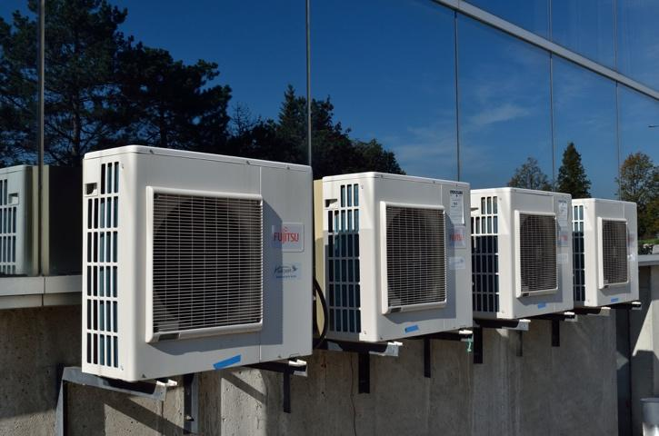

|  |  |
| --- | --- |
| **HVAC upgrade** | |
| **Project lifetime** | 7 |
| **Upfront Capital Cost (CAPEX)** | $100,000 |
| **Exp. Annual Savings** | $10,000 |
| **Exp. Annual Operation Cost (OPEX)** | $1,000 |
| **Annual Emissions Reductions (tCO2e)** | 40 |
| **Interest rate** | 8% p.a. |

**Project description:** Upgrading the Heating Ventilation and Air Conditioning (HVAC) system in an office building can result in higher performance and therefore lower power use and emissions.

**PROJECT 3**



|  |  |
| --- | --- |
| **Biofuel switch** | |
| **Project lifetime** | 6 |
| **Upfront Capital Cost (CAPEX)** | $9,000 |
| **Annual Savings** | $4,000 |
| **Avoided diesel (L)** | 80,000 |
| **Annual Operation Cost (OPEX)** | $500 |
| **Annual Emissions Reductions (tCO2e)** | ??? |
| **Diesel emissions factor (kgCO2e/L)** | 2.7 |
| **Interest rate** | 8% p.a. |

**Project description:** Biodiesel is made from renewable biomass, and has a much lower emissions intensity than conventional diesel.

**PROJECT 4**

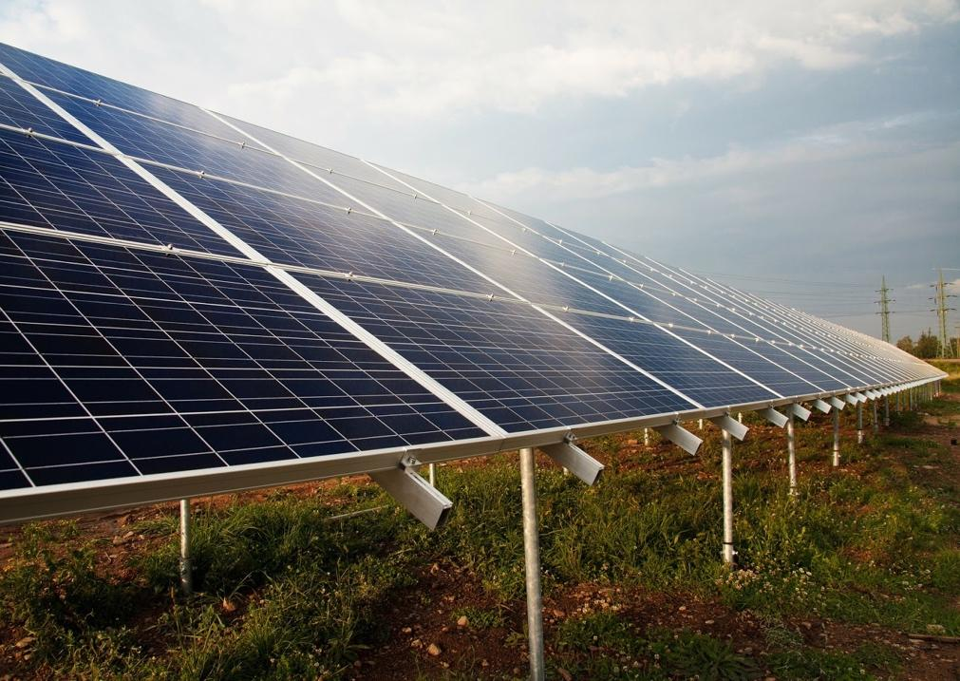

|  |  |
| --- | --- |
| **Solar PV system** | |
| **Project lifetime** | 7 |
| **Upfront Capital Cost (CAPEX)** | $1,000,000 |
| **Annual Savings** | $150,000 |
| **kWh savings** | 900,000 |
| **Annual Operation Cost (OPEX)** | $10,000 |
| **Avoided Annual Emissions (tCO2e)** | ??? |
| **Scope 2 electricity emissions factor (kgCO2e/kWh)** | 0.58 |
| **Interest rate** | 8% p.a. |

**Project description:** Installing a roof-top solar PV system can generate power which is used to replace (avoid) power purchase from the grid and associated emissions.